**Corda Node Setup**

Node configuration and other important files/directories

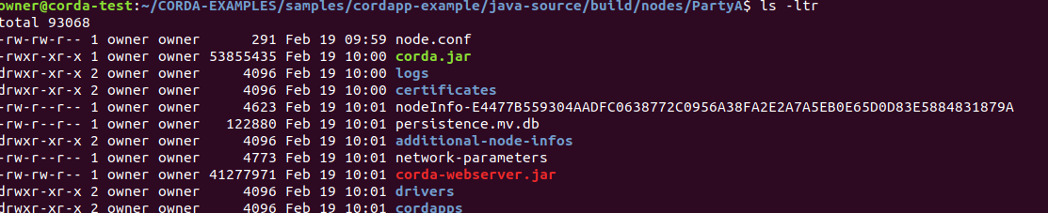

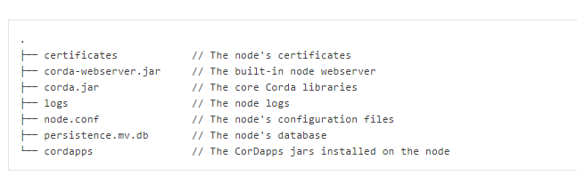

**Certificate information – All the Keys are stored inside this directory**



**Step 1: New Folder and its content**

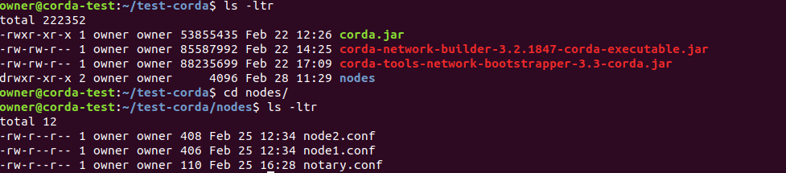

**Step 2: invoking network boot strapped**

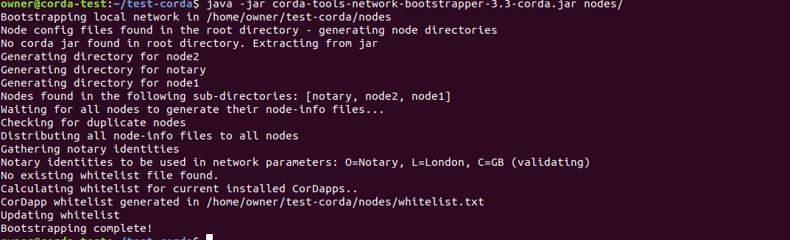

**Step 3: Looking at the contents created inside the directory**

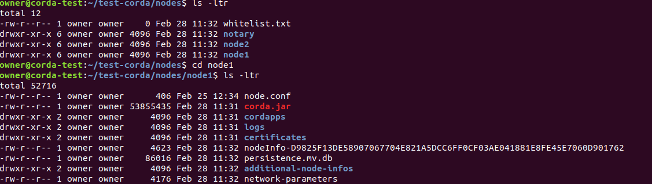

* Certificates, network-parameters etc. are bootstrapped.
* Each node has a node key

**Step 4: Looking at additional nodes directory where each node has its own information**



**Step 5: Each node is bootstrapped with its own certificate**

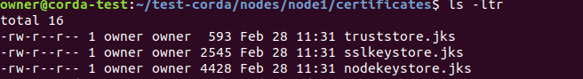

**Configuration files used for the above set up**

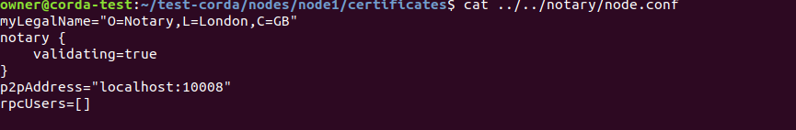

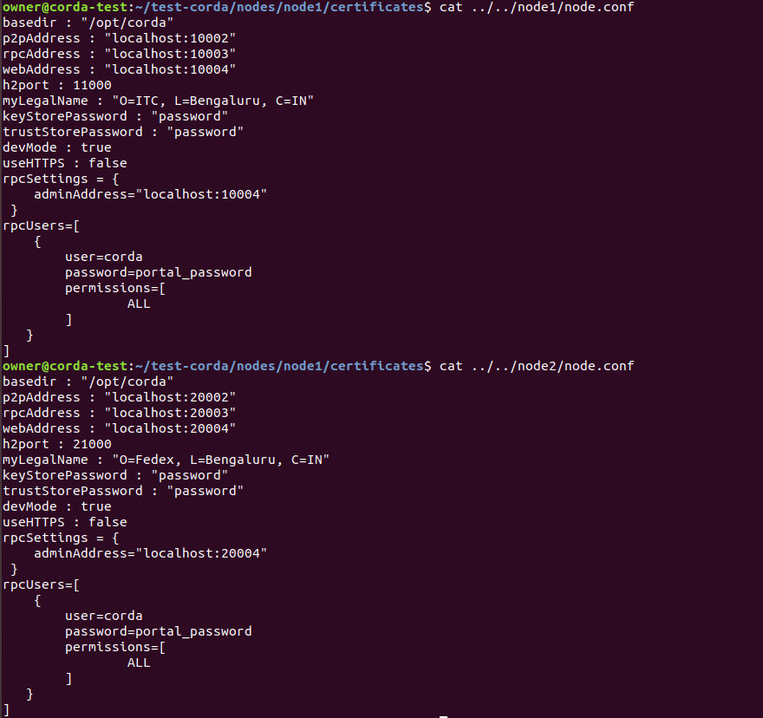

**Creating a custom certificate and using it for bootstrap**

**Step1 :**

keytool is used to generate JKS and the information is viewed using keystore password (password123)



